Sweet Potato Salad

* [Nutrition](http://www.beachbody.com/beachbodyblog/category/nutrition)

* [Recipes](http://www.beachbody.com/beachbodyblog/category/nutrition/recipes)

May 2, 2014

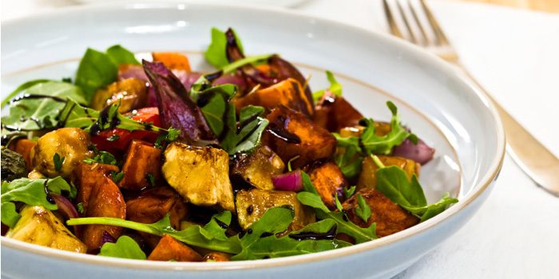

This salad is topped with hearty sweet potatoes. They’re a superfood high in beta-carotene, potassium, and manganese. Pumpkin seeds add extra crunch! [**Click here to have our in-house nutritionist show you how to make this salad**](http://www.beachbody.com/beachbodyblog/nutrition/make-healthy-versions-classic-summer-recipes)!

**Total Time:** 1 hour 15 min.  
**Prep Time:** 15 min.  
**Cooking Time:** 30 min.  
**Yield:** 2 servings

**Ingredients:**  
1 Tbsp. extra-virgin olive oil  
1½ tsp. red wine vinegar  
1 tsp. fresh lemon juice  
½ tsp. raw honey (or pure maple syrup)  
1 dash Himalayan salt (or sea salt)  
1 tsp. chopped fresh herbs (like basil, oregano or parsley) (to taste; optional)  
1 medium baked sweet potato, peeled and cut into ½-inch cubes  
1 medium green apple, diced  
½ medium red bell pepper, diced  
1 stalk green onion, finely sliced  
2 Tbsp. finely chopped fresh cilantro  
4 cups fresh arugula  
2 Tbsp. pumpkin seed kernels, toasted (or chopped raw walnuts)

**Preparation:**  
1. Combine oil, vinegar, lemon juice, honey, salt, and herbs (if desired) in a medium bowl; whisk to blend.  
Set aside.  
2. Combine sweet potato, apple, bell pepper, onion, and cilantro in a large bowl; mix well.  
3. Drizzle dressing over sweet potato mixture; toss gently to blend.  
4. Place even amounts of arugula on two serving plates; top each with sweet potato mixture and sprinkle with pumpkin seeds.

**Tip:** Bake fork-pierced sweet potato at 450° F for 30 to 40 minutes or until just tender. Do not over bake; cool.

